**Modeling Frequency Division Multiplexing/DE-multiplexing**

**Lab # 09**



**Fall 2023**

**CSE-402L Digital Signal Processing Lab**

Submitted by: **Ali Asghar**

Registration No.: **21PWCSE2059**

Class Section: **C**

“On my honor, as student of University of Engineering and Technology, I have neither given nor received unauthorized assistance on this academic work.”

Submitted to:

**Dr. Yasir Saleem Afridi**

Date:

**8th January 2023**

**Department of Computer Systems Engineering**

**University of Engineering and Technology, Peshawar**

**CSE 402L: Digital Signal Processing**

|  |  |  |  |  |
| --- | --- | --- | --- | --- |
| **Demonstration of Concepts** | **Poor (Does not meet expectation (1))**  The student failed to demonstrate a clear understanding of the assignment concepts | **Fair (Meet Expectation (2-3))**  The student demonstrated a clear understanding of some of the assignment concepts | **Good (Exceeds Expectation (4-5)**  The student demonstrated a clear understanding of the assignment concepts | **Score**  **30%** |
| **Accuracy** | The student completed ( <50%) tasks and provided MATLAB code and/or Simulink models with errors. Outputs shown are not correct in form of graphs (no labels) and/or tables along with incorrect analysis or remarks. | The student completed partial tasks (50% - <90%) with accurate MATLAB code and/or Simulink models. Correct outputs are shown in form of graphs (without labels) and/or tables along with correct analysis or remarks. | The student completed all required tasks (90%-100%) with accurate MATLAB code and/or Simulink models. Correct outputs are shown in form of labeled graphs and/or tables along with correct analysis or remarks. | **30%** |
| **Following Directions** | The student clearly failed to follow the verbal and written instructions to successfully complete the lab | The student failed to follow the some of the verbal and written instructions to successfully complete all requirements of the lab | The student followed the verbal and written instructions to successfully complete requirements of the lab | **20%** |
| **Time Utilization** | The student failed to complete even part of the lab in the allotted amount of time | The student failed to complete the entire lab in the allotted amount of time | The student completed the lab in its entirety in the allotted amount of time | **20%** |

Tasks:

Step 1 & 2:

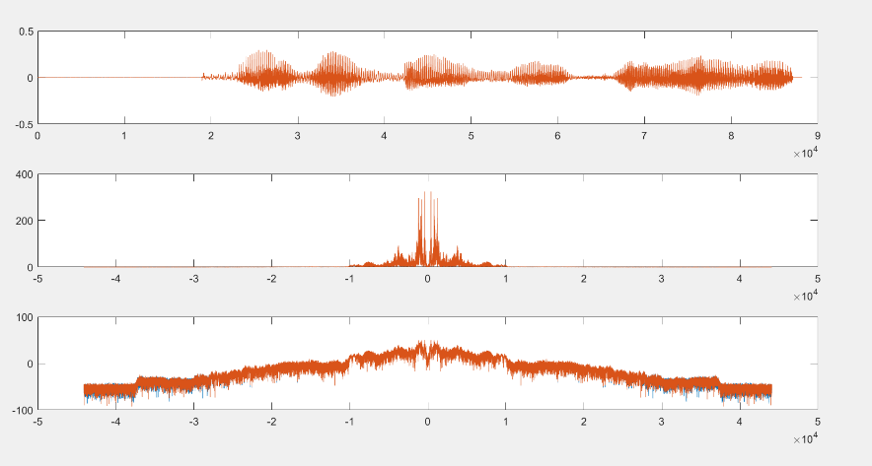**Signal 1:**

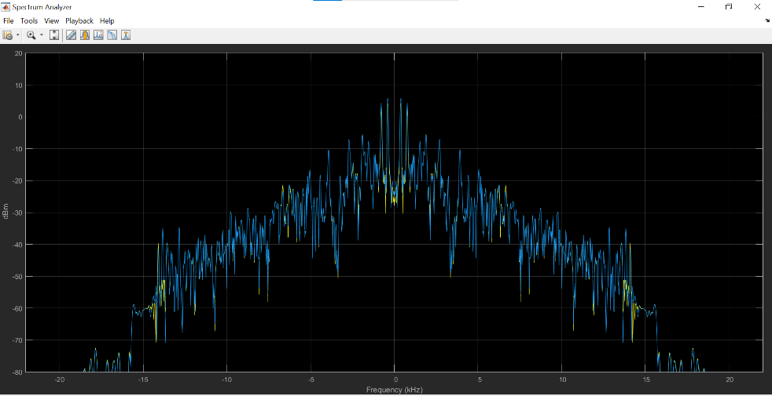**Signal 2:**

**Signal 3:**

Step 3 & 4:

**Signal 1:**

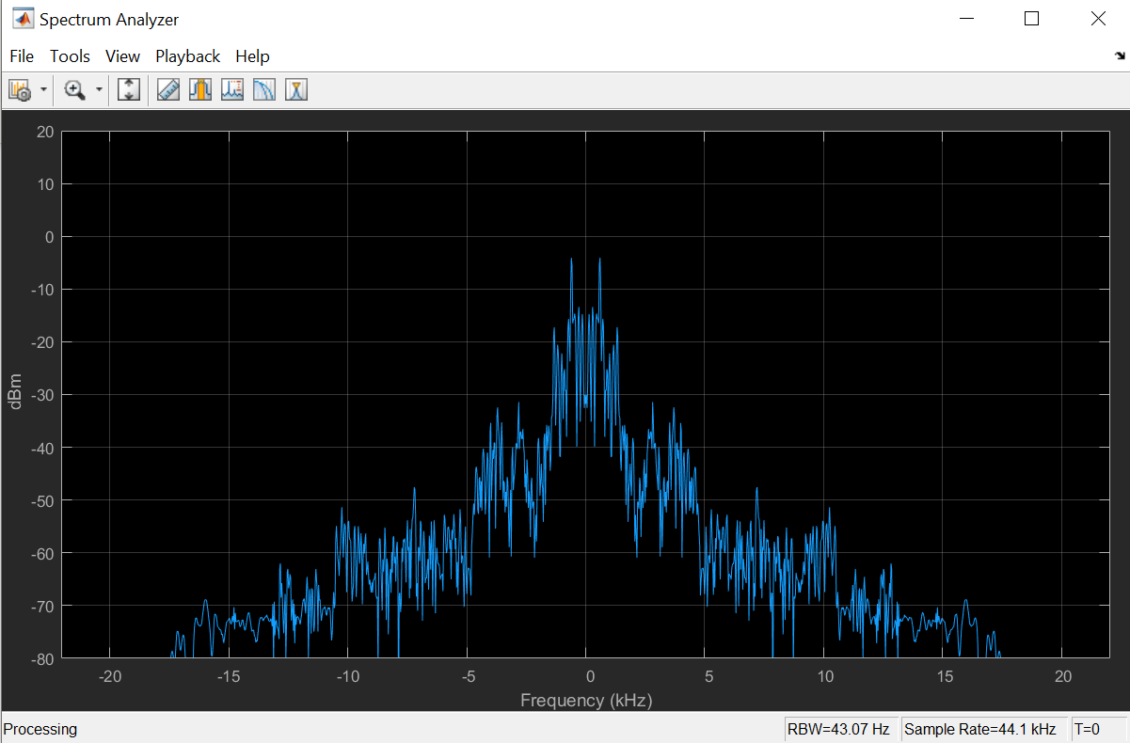

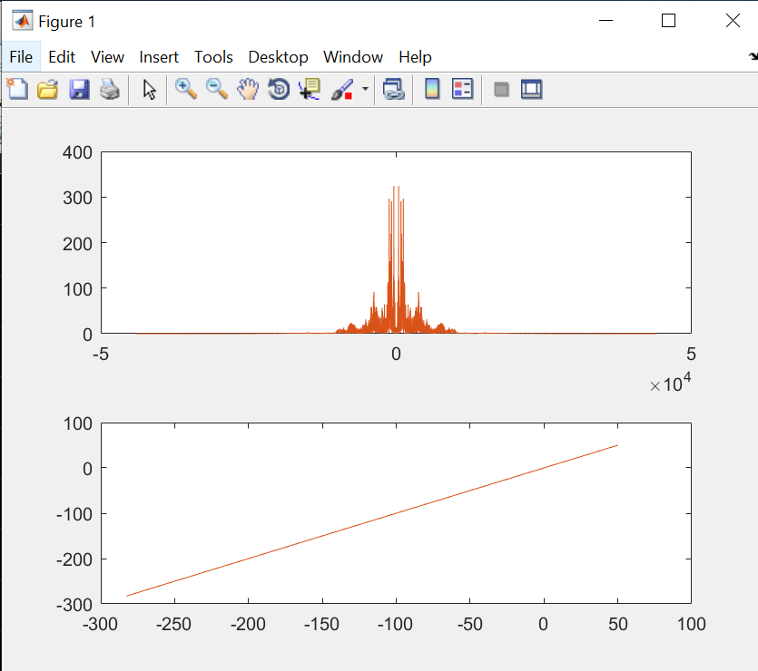

Signal 2:**

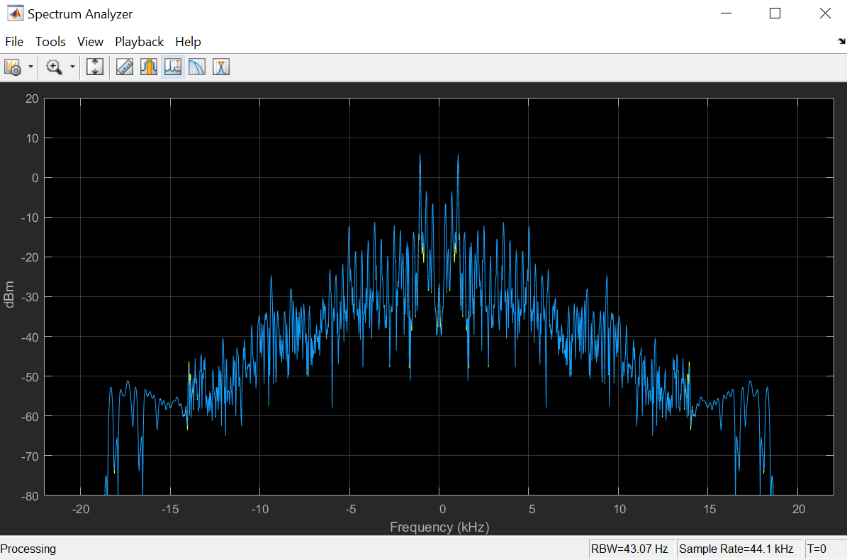**Signal 3:**

**Listen the signals again and observe the difference in quality. Why?**

**Answer: Because we have attenuated some of the high frequency components(Mostly Causing Noise). That is the reason we’re hearing it differently.**

Step 5,6,7,8,9 & 10:

Modulated + Multiplexed Signals

Frequency Spectrum of Demodulated signals

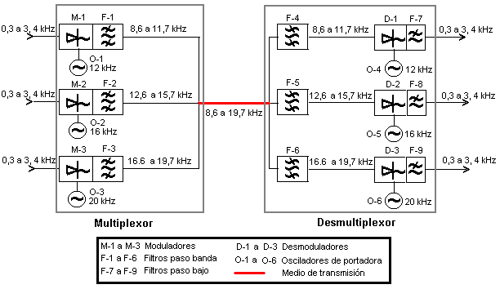

Code:

Lab9_Loading.m

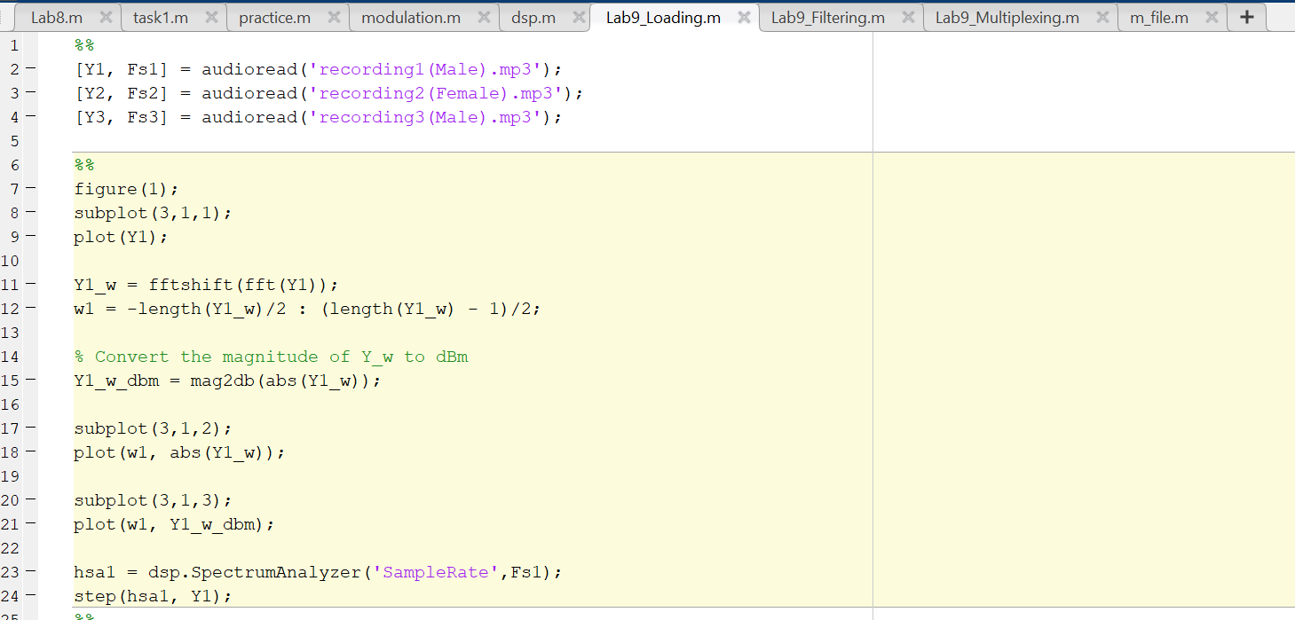

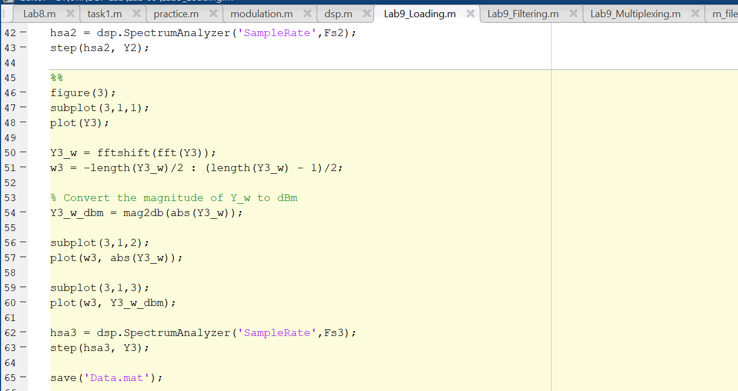

Lab9_Filtering.m

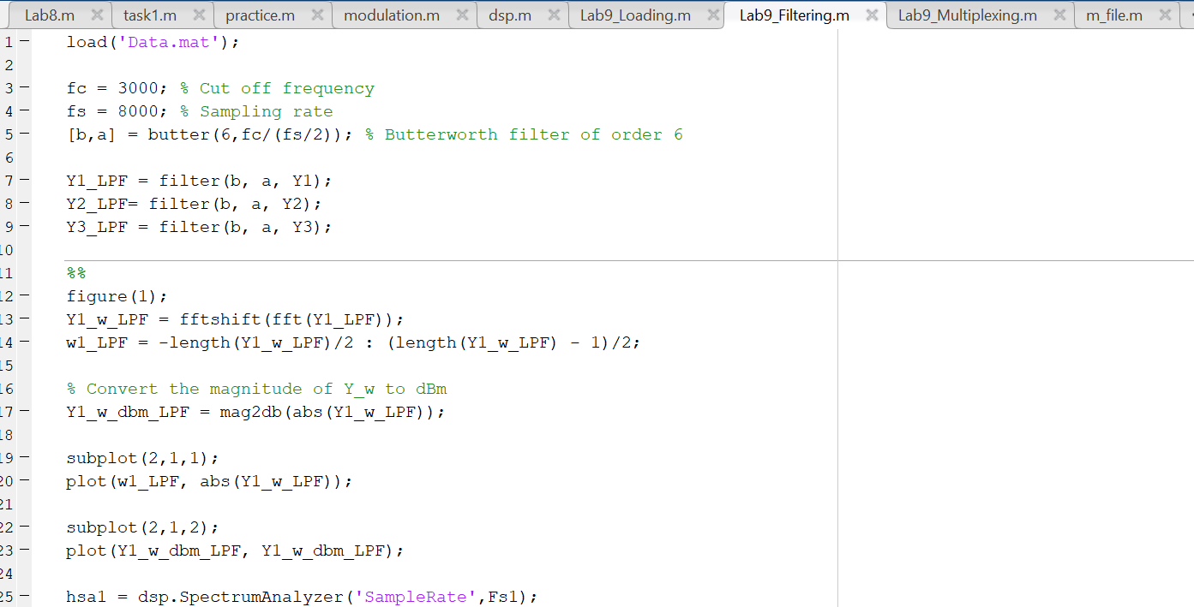

Lab9_Multiplexing.m

**Conclusion:**

We modulated three speech signals and add noise to it to simulate the behavior of channel and demodulated the signal to obtain the original signal.